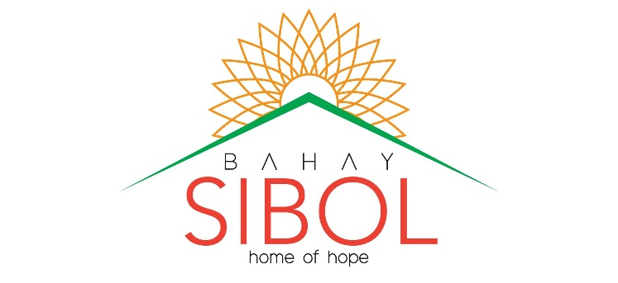
“For there is hope of a tree, if it be cut down, that it will sprout again, and that the tender branch thereof will not cease.”
Job 14:7

December 17, 2018

Dear Friends and Partners,

This season, as we celebrate the birth of Jesus Christ as God’s greatest gift to the world, we send greetings for a Joyful and Merry Christmas! As we thank Him for his most precious gift of salvation, we also want to express our gratitutde for His many gifts to Bahay Sibol this year. They were abundant, always right on time and exactly what was needed. Likewise, to each of you who were a channel of those blessings, a sincere thanks for your love, care and partnership with us in this challenging, yet beautiful ministry.
We would like to say how grateful we were to have received several large, one-time donations in recent months for the completion and furnishing of the building that will be our community out reach center: Hope Baptist Church, day care and tutorial center. These large amounts enable us to finish big projects and pay off big needs, without disturbing regular funds set aside to pay the daily needs of the home and children.
At the time of our last update in July, we were caring for 19 children with a basic staff of 5 full time workers and several volunteers. We are now caring for 28 children. With the large growth in the number of kids in just a short time, there is also a growth in needs. The major areas of need that have increased for us over recent months are: more staff, utilities, groceries, hygiene and other personal needs, education and clothing for the children. Growth in number also leads to more adminstrative needs such as secretarial and social worker’s paperwork, documentations, transportation to meetings, hearings, and investigations of family situations with neglect and abuse cases. Another major areas of increased need include medical attention and counselling services for those with certain abuse and neglect cases. As you can probably already imagine, all of these additional needs mean a huge increase in the regular monthly budget. If you are a regular monthly supporter we want to say how much we appreciate your partnership and dedication to these children. If you have not yet made a commitment to regular monthly support, please consider how you might be able to help meet our needs on a regular basis.
For a more detailed updates and weekly progress of Bahay Sibol, please visit our Facebook page; we keep it updated on a regular basis for your information and to address our prayer needs.

Merry Christmas and a Happy New Year from OUR HOME to YOURS!
Phone: +63-922-423-2138
Phone: +63-44-815-4959
E-mail: gormleys@live.com
FACEBOOK: Bahay Sibol - Home of Hope
A Children’s Home Ministry of:
Calvary Baptist Church
9-10 Genesis Ave. Sarmiento Townville
Poblacion I, City of SJDM 3023 Philippines
SUPPORT ADDRESS, send donations to:
BEMA
4744 Winchester Pike,
Columbus, OH 43232, USA

