April/May 2018

Dear Friends,

These months have kept us busy, as we had several special days at the church and welcomed back the Inman family from their deputation travels.

The church people got excited about inviting their friends and neighbors to “Bring a Friend to Church Day.” On this Sunday, we had a raffle and special food. Many first-time visitors won prizes, which included a rice cooker, a house fan, and five-pound bags of rice. One of our faithful members, Pi Nong, brought 7 visitors that day, and she was thrilled to have several of her ticket numbers read off during the raffle. Three different families from “Bring a Friend to Church Day” have attended services since that day and have even invited their family and friends to visit the church. It has been a blessing to see the Lord build the church by way of visiting, soul winning, and the personal testimonies of our faithful members.

On “Back to School” Sunday, we encouraged our faithful children and teens to invite their friends. Each child who came received a gift bag with school supplies and goodies. We had a carnival set up with games and prizes; two bikes were raffled, and hot dogs were grilled for lunch.

Pi Som was saved two months ago and has become faithful to church since that day, but she has waited to get baptized. A few weeks ago, Missy was sitting with Pi Som in church. When the invitation started, Pi Som asked Missy why baptism was important. After they talked for a while, her face lit up with understanding, and she said, “Can I get baptized today? I’m ready to show everyone I’m not ashamed to be a Christian!” What a joy to witness these new believers as they take these steps of faith.

As we daily give out the Gospel, make visits, and take time to go with different groups from the church, we find that the people are open, ready to listen, and wanting the truth. One day while out visiting, I had the opportunity to see an elderly man receive Jesus after he heard the Gospel for the first time. When we finished talking, he asked how he could have this free gift of eternal life! I know I sound like a broken record, but the fields are white to harvest here in Hua Hin, Thailand, and hearts are searching. We pray that the Lord continues to give us the boldness to continue the work He has given us to do.

Mark and Lauren completed another year of school (5th and 6th grades with the Abeka DVD homeschooling program) and are more than happy to be on Summer Break. I am pretty sure Missy is more excited than they are since she is their teacher/monitor.

God unexpectedly provided money from a family member for Missy to fly to America in May to surprise her parents for their retirement party. This was the first time in 16 years (since we have been married) that Missy has been able to surprise her family with a visit. It was a wonderful trip and gave Missy a chance to have extra time with her mom and dad and extended family. The kids and I took one for the team and stayed in Thailand. That was an interesting 10 days apart from my dear wife. We definitely appreciate her all that much more and all that she does for our family and ministry!

On Missy’s return trip back to Thailand, she had a delay and a missed flight due to weather. This caused her to get a hotel in Dallas, Texas, for a night. The next day she met the breakfast-room manager at the hotel. They started talking about the weather and delayed flights. The conversation led to Jesus, and Missy had the opportunity to witness to Lee (a 60-something-year-old man). Lee shared his salvation testimony and said that he had strayed from the Lord in recent days. Before they parted ways, Lee said with tears in his eyes, “I believe God sent you to me today to remind me that He hasn’t given up on me yet.” We are thankful for this small detour in Missy’s trip so that she could meet Lee.
On April 27, we welcomed the Inmans back from their deputation travels. It’s been wonderful to have them back! Then at the end of May, we were excited to have Jon and Brittany Beil back for their survey trip. The Beils are at 50% of their needed support to join the team as our newest missionaries. They will take this time to start basic language studies and get to know the church, ministries, and the people. We have also had the wonderful privilege of having our nephew, Matthew Bosje, here to spend the summer working and helping in the ministry. He is also on the path to joining the team in the near future. Matthew spent five years in Thailand with his family before he went to Bible college in America. He is fluent in the language and has a heart for the people here. Please pray as the Lord directs these young people for the Gospel’s sake!

For Him,

Tim Shook

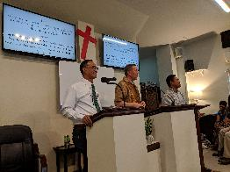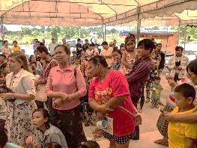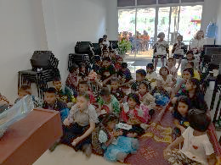

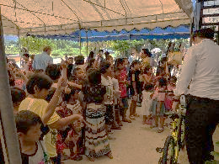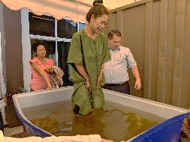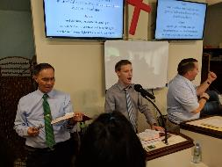

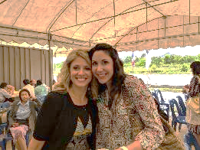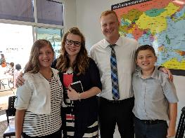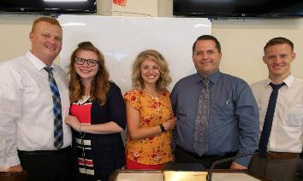

Picture descriptions from the top row, right to left:

(First Row) Brother Chad Inman sharing his deputation testimony; Bring a Friend to Church Sunday;

Junior church

(Second Row) Back to School Sunday; Pi Som’s baptism; Matthew Bosje leading the congregational music

(Third Row) Missy & Mrs. Sarah Inman; Mark & Lauren with the Beils; The Beils & Matthew Bosje with us at the church

