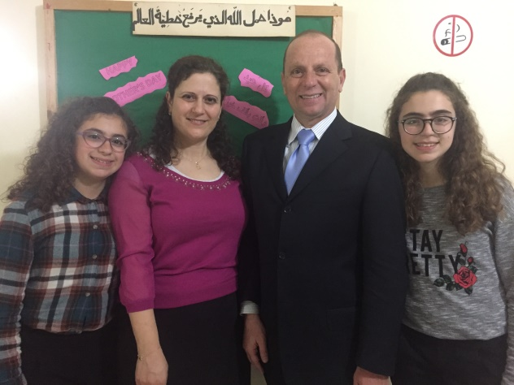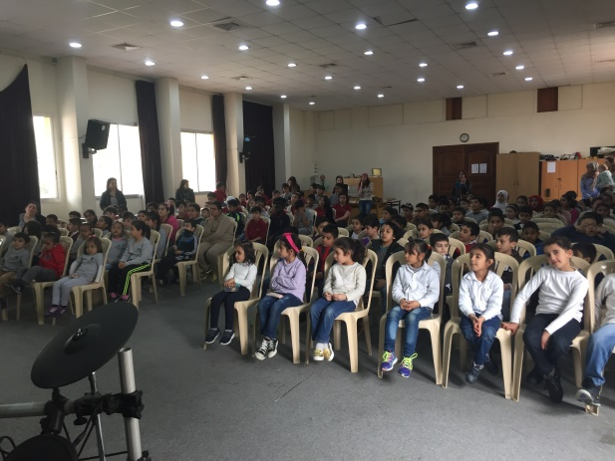



Dear praying Friends

“Cast thy bread upon the waters: for thou shalt find it after many days” Ecc. 11:1

Thanks God for your faithfulness in prayer and financial support, may the Lord bless you and enlarge your ministry.

**Ministry:**

Praise the Lord our ministry is doing great; the Lord is blessing us with many Iraqis and Syrian Refugees which they flee from their country because of war. Those refugees are in need have shelter and food we try to help them**. Friends, the need is so great, we covet your help in this matter if you can help.**

Our ministry with the children is doing great. We are excited, on July, we will have our children and youth conference and in August our annual family conference.

Our ministry on Sunday night is great, there are many people coming to the Lord Jesus Christ. Praise the Lord soon, we will baptize four people, and two of them are Muslim.

We have home bible study on Wednesday night, few people attending this ministry. And we are visiting and witnessing to many people in our village even though we have many obstacles but the Lord is using us in a mighty way and lead our path. Please pray for Elie and Gaby in our village especially Gaby because is facing persecution from his family and the catholic churches because he accepted the Lord his savior in our ministry.

The situation in Lebanon is very difficult now. There are many refugees in Lebanon because of the war in the Middle East, and that affected the economic and life in Lebanon. Lebanese people are suffering in many areas in life. Please pray for this problem to be solved and those refugees return to their country safety.

Thank you for your support and your prayers especially in this time. Please continue praying for our financial support because we lack more support. If you can help send your funds to our mission board. Thank you again, May the Lord bless you.

In Christ

Hani Dekho

**Lebanon Address**  **Board Address Sending Church**

Hani Dekho B.E.M.A N.Auburn Hills Baptist Ch.

Haret El Deir St. 744 Winchester Pike 3889 N.Squirrel Rd.

Salim Nassar Bldg 2 floor Columbus, OH 43232 Auburn Hills Mi 48326

Facing coral station- kafarchima phone: (614)833-0488 Pastor Dr. John Marine

Phone (961) 327-2386 BEMAMissions@sbcglobal.net

hanidekho@yahoo.com